Cloning the Dragon

By Jerry Veneman.

The beauty of the exploitation craze of the 60’s and 70’s is that it has something to offer for everyone. There’s blaxploitation for afro-Americans and wannabe pimps, nunsploitation for those who are troubled by their conservative childhood, nazisploitation: for sick weirdo’s like me and sexploitation for everyone.
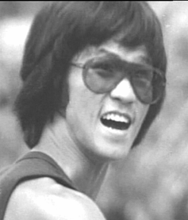
And then there’s Bruceploitation, a subgenre from Hong Kong created by producers who wanted to cash in on the popularity and mysterious death of Bruce Lee who died on the 20th of July, 1973.
The mysterious circumstances of his death (murder? Allergy to painkillers?), his young age (32 years old) and the existence of footage shot for his uncompleted movie “Game of Death” had audiences begging for more.
And they probably got more than they asked for. Between 1974 and 1982 a huge amount of Bruce Lee look-alikes, with aliases like Bruce Liang, Bruce Lai, Bruce Thai, Dragon Lee, Bronson Lee etc. stormed the Asian cinema’s. Listing all Bruce Lee exploitation movies here is practically impossible. There are just too many. So I’ll just name some of my personal favourites here: the weirdest!

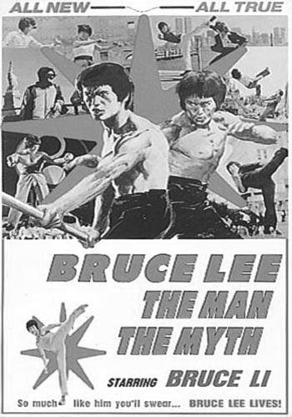
The first Bruceploitation film is probably Dragon Story (1974), a cheaply shot biopic that didn’t take the facts of Bruce’s life too seriously. In stead it focuses on the relation between Bruce Lee and Betty Ting Pei, the actress who he spent his last hours with. Betty (who plays herself in this movie) never reacted to the rumours about a love affair between her and Bruce, out of respect for the deceased, but Dragon Story leaves little to the imagination. After she loses their love child in a miscarriage Betty tries to commit suicide. Dragon Story is sleaze at its worst, only topped by Bruce Lee: His Last Days, His Last Nights from 1976. When Betty sobs in one of the first scenes: “I was always teased at school when I was young. I had no friends” you know what’s coming. It basically tells the same story but includes scenes of a drunken Bruce Lee popping pills and some soft-core porn scenes of him and poor Betty.
Both movies are pretty bad and to most people probably unwatchable. But Dragon Story did feature the first and probably best known clone in his acting debut: Ho Chung Toa aka Bruce Li, a gymnastics teacher from Korea.
Bruce Li is not only the first professional imitator, but also the clone that made a record number of 6 biopics.
The most successful movie about Bruce’s life was
Bruce Lee: The Man, The Myth (1976). This movie basically tells the story of Bruce’s life the way it really happened; with of course a few strange plot twists to spice things up. In order to keep the audience interested there’s a weird subplot about Bruce fighting a few Italian mobsters; a not too subtle effort to cash in on the popularity of The Godfather.
In another bizarre scene we see Bruce in his gym attaching electrodes to his body that are part of a futuristic machine that looks more like a large box with some brightly coloured disco lights in it. He obviously tries to train his muscles through small electroshocks. But Bruce always pushed his limits, which causes him to almost electrocute himself in this scene.
The Man, The Myth is, especially for Hong Kong standards, a well made movie and certainly more entertaining than that big budget Hollywood crap Dragon from 1993.

I’m sure you’d agree when I say that the best exploitation cinema is the trashiest exploitation cinema. And when it comes to the raunchiest movies of this Bruceploitation, there’s only one king: my personal favourite Bruce Le (real name: Wong Kin Lung).
Le, a short muscled guy with an oversized Bruce Lee haircut, was probably the worst actor of all clones but also one of the best fighters.
Bruce Le wasn’t really trying to capture the life of his role model on film. He just used Bruce Lee as a starting point to write, direct and star in his trashy no-budget movies.

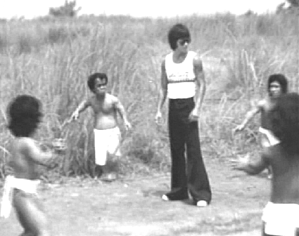
Like his movie King Boxer 2 (1978?) a movie that has nothing to do with Lo Lieh’s classic from 1973. In this movie, Le tries to find his uncle who has a map that leads to a hidden treasure. Of course, Le must find that Japanese WW2 gold before the gangsters do. The story, like in most of Le’s movies, is just an excuse to show lots of Kung Fu battles where he has to defeat a wide range of strange opponents. Lita Vasques plays a rather attractive lady mobster, but her gang of Shaolin Bronze men and midget hit men (dressed in groovy shirts and tiny bellbottoms) are completely ridiculous. In one scene, which almost looks like an Asian tribute to Gulliver’s Travels, Bruce is trapped by the little guys and tied to the ground. But of course they’re no match for his furious Tiger Claws.

Bruce Le’s best and probably one of the wackiest Bruceploitation films is
Clones of Bruce Lee (1977) produced by pulp specialist Dick Randall.
According to this movie, the British Secret Service took some blood from the deceased Bruce Lee and used his DNA to produce 3 full grown clones:
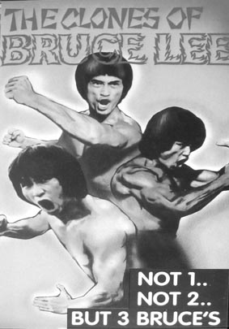
Bruce 1 (Bruce Le), Bruce 2 (Dragon Lee, a kind of long haired Bruce with the body of Arnold Schwarzenegger) and of course Bruce 3 (Bruce Tai). First, the three Bruces get intensive training by two Kung Fu regulars Kong Do and muscleman Bolo Yeung. After that they’re used by the government to liquidate dangerous Asian criminals.
In one of the episodes, Bruce 1 and Bruce 3 travel to Thailand to assassinate a crazy scientist (“First I’ll conquer Thailand and then I’ll conquer the world! BWAHAHA”) who’s working on a secret serum that turns men into (here they are again…!) Shaolin Bronze Men.
When the Bruces fight these metal soldiers they seem unbeatable. Every kick or strike is answered by a loud Bong sound of their bronze skin. At this point one of the Bruces gets a flashback. He remembers a woman telling him about the dangers of poisonous grass. He then forces his shining opponents to graze like cows and before you know it they’re dropping like flies.
A very weird scene but not as strange as the film’s surreal climax where the clones’ creator (played by Return of the Dragon’s John Benn) forces the brainwashed Bruces to fight each other to death. Just add a few random scenes of naked Chinese chicks on the beach and you’ve got an instant trash classic.

In the early 80’s the glory days of Bruce Lee exploitation were almost over. The clones had to take a step back and make room for another deadly martial artist: the ninja. But of course: not without a fight.
In Ninja Strikes Back aka Eye Of The Dragon (1982), Bruce plays a henchman that retires from the business after spending some time in jail.
His former gang doesn’t really agree and kill off his girlfriend, his father and kidnap his sister. Now, there’s only one thing left for Bruce: Revenge!
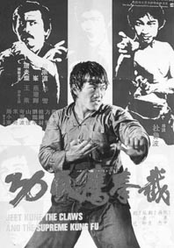
He doesn’t only have to fight lots of ninja’s but also a dangerous killer called Oddjob.
And, yes, that’s the same killer from James Bond’s Goldfinger, once again played by wrestler Harold Sakata.
To make sure there’s no mistake about that, Harold tries to kill Bruce with a razor edged hat while the soundtrack plays the well known James Bond theme. When that doesn’t seem to work Oddjob shows his secret weapon. A metallic glove with 5 gold fingers!
The final fight is between Bruce and the leader of the ninja’s (played by leg master Hwang Jang Lee). Here Le reprises Bruce Lee’s famous duel against Chuck Norris from Return of the Dragon in the Collosseum in Rome. In a strange cartoonish version of x-ray vision we see Bruce breaking his opponent’s leg and busting his ribs until finally his heart stops beating. A crazy ending to an even crazier movie.

If you think midget assassins, ninja’s and bronze warriors are weird, you really should see
Dragon Lives Again (1976). After his death Bruce Lee’s spirit travels to hell (!!!) where he has to fight the master demon. This evil master gets help from people like James Bond, Clint Eastwood, Emanuelle and Dracula. Fortunately Bruce gets help from Caine, from the Kung Fu TV-series and… Popeye the Sailor man! After many battles, Bruce defeats the evil army using his “third leg technique” (and yes, he’s fighting with his dick here).
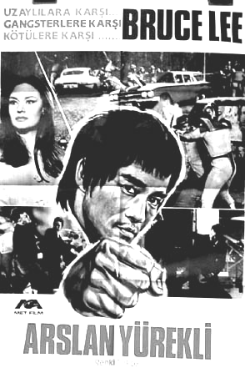
Basically everything about this movie is just plain wrong. First of all, the clone, played by Bruce Liang, doesn’t look a bit like Bruce Lee. Even one of the demons sighs: “That’s Bruce Lee? It surely doesn’t look like him.” “Of course not”, one of his fellow devils answers; “In hell everyone looks different.”
Then there are his enemies. Bruce fighting existing movie legends is weird enough, but to make it even more ridiculous: they’re all played by Chinese.
Of course the movie is all tongue-in-cheek, but it’s a kind of humour that probably has the real Bruce rolling in his grave.

For a short time Bruceploitation was big business. Close to 200 movies were made in a 6 year period. The exact number is pure speculation since most of them were only released in Asia. Even European schlock directors tried to make their own entries into this strange genre.
Jess Franco directed La Sombra de Judoka contra Doktor Wong (1984 starring Bruce Lyn) and some people claim that Bruce Lee Fights Back From The Grave director Doo-Yong Lee is none other then Umberto Lenzi.
There are also rumours about the existence of a Brazilian movie called Bruce Lee vs. Gay Power, which is mentioned in Pete Tombs’ Modo Macabro and there seems to be a completed script for Ilsa meets Bruce Lee in the Bermuda Triangle, a movie that strangely enough was never produced.
Thanks to late night TV and the video boom of the late 70’s, early 80’s these movies became a success in western countries too.

Nowadays it’s surprising to see lots of Bruceploitation flicks appearing on cheap dvd’s.
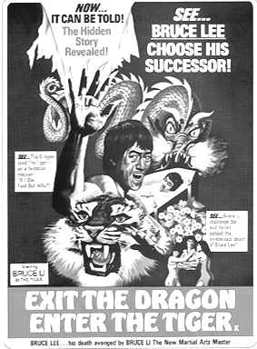
One of the reasons for this could be the 30th anniversary of Bruce Lee’s death.But it’s more likely that the fact that DVD companies don’t really have to worry about copyrights has something to do with it. Asian directors and producers, who didn’t care about copyrights themselves when it came to music and stock footage, aren’t likely to sue American distributors over cheaply made trash cinema from thirty years ago.
Whatever the reason may be, it’s a great opportunity for a new generation to see these films and for old school collectors to replace their low quality VHS-tapes with low quality DVD’s.

Now what’s the appeal of those old movies where little Chinese Bruce Lee imitators run across the screen? I’ve asked myself that question many times since I’m only one of the few people who are obsessed with these movies. I think it’s because they made so many of these movies, they started to have their own sense of logic and rules. It’s like you’re watching footage from another universe populated by wacky doppelgangers of a lost hero from planet earth.

Like I said, a good Bruceploitation flick has to meet certain conditions:
- The main actor has got to have an alias resembling his predecessor’s name, like Bruce Lai, Bruce Lei, Bruce Liang etc.
- There has to be at least one scene where the clone wears Bruce’s yellow black tracksuit from Game of Death. No, Tarantino was not the first one to recycle this idea in Kill Bill. There were about 50 Chinese before him.
- The dubbing has to be total shit. Robotic voices, bad English and laughable synchronisation.
- The soundtrack has to be a mixture of other ‘borrowed’ soundtracks and music including: James Bond music (For Your Eyes Only and Thunderball are favourites), Ennio Morricone (Once Upon A Time In The West), Isaac Hayes or other blaxploitation and disco music, the Enter The Dragon soundtrack and a variety of musac versions of popular songs from the 70’s. (As you can see again, Tarantino is hardly a pioneer when it comes to soundtracks either).
- At least one scene where the clone is fighting Bolo Yeung.

So if you’re in for a fun night of bad videos, invite a couple of friends and enter the hypnotic world of Bruce Lee clones! And just like it is with Chinese food: few six packs of Heineken to wash it all down with is highly recommended

Jerry

Thanks to Lee for letting me use some images from his site: http://www.bruceleeclones.co.uk/

